Test plan

Test 1 - Running the GUI

The GUI is run from the CustomerLogin.java

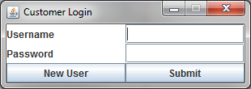

Reflective Notes

When creating the program I designed the code based on how I thought the GUI should look from the user’s point of view. The design needed to be clear and well spaced so that it wasn’t too complicated and intimidating to use. I decided have default font and a white background on the GUI to make it look professional. Using grid layout for the layout design and making the GUI non-resizable made the GUI layout easier.

Test 2 - Pressing the New User JButton

The GUI is run from the CustomerLogin.java



When button was clicked the Register GUI successfully opened.

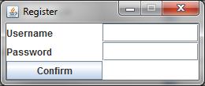

Reflective Notes

Again the design needed to be clear and well spaced so that it wasn’t too complicated and intimidating to use. I decided have default font and a white background on the GUI to make it look professional. Using grid layout for the layout design and making the GUI non-resizable made the GUI layout easier.

Test 3 - Submitting information to be registered

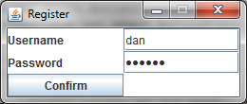



Username and password successfully registered into the CL.txt file.

Reflective Notes

I decided to hold the customer information in the text file in the format username, password. This way it is easier to see the information.

Test 4 - Logging in

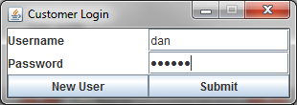

Reflective Notes

Although the user had been registered correctly the file reader in the Submit action Listener was not correct and therefore did not work. Due to time constraint this issue was not fixed making logging in not possible.

Test 5 - Order JButton from the Account

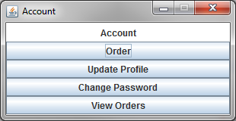

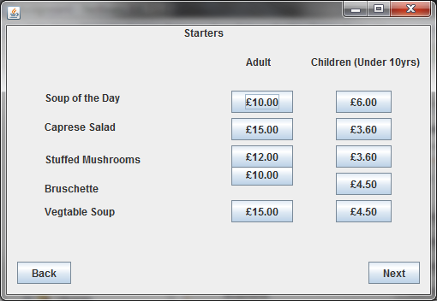

Reflective Notes

Although the user can't log in the Account GUI still works and the Order JButton on the Account GUI successfully opens up the starters menu.

Test 6 - Update Profile JButton from the Account



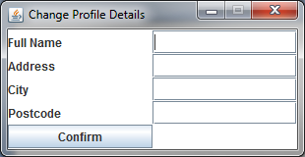

Reflective Notes

The Update Profile JButton successfully opens the Change Profile Details GUI when clicked.

Test 7 - Change Password JButton from the Account



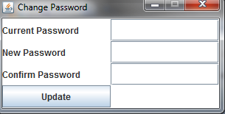

Reflective Notes

The Change Password JButton successfully opens the Change Password GUI when clicked

Test 8 - View Orders JButton from the Account



Reflective Notes

Due to time constraints the ViewOrders.java was never created and therefore this button does not work. If it did the GUI would show the users previous orders with dates.

Test 9 - Ordering food from the Starters GUI



Reflective Notes

Due to time constraints the menu is unfinished. The back JButton takes the user back to Account GUI. The Next JButton takes the user to the Mains GUI. The rest of the JButton however do nothing as there is no action listener on them to record the meal choices.

Test 10 - Ordering food from the Mains GUI

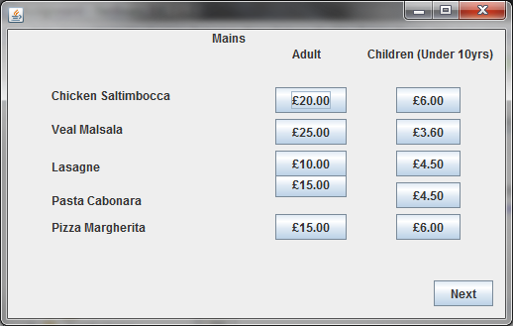

Reflective Notes

Due to time constraints the menu is unfinished. The back JButton takes the user back to Account GUI. The Next JButton takes the user to the Mains GUI. The rest of the JButton however do nothing as there is no action listener on them to record the meal choices.

Test 11 - Saving profile data using the Change Profile Details GUI

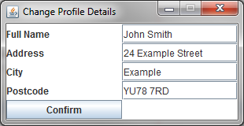

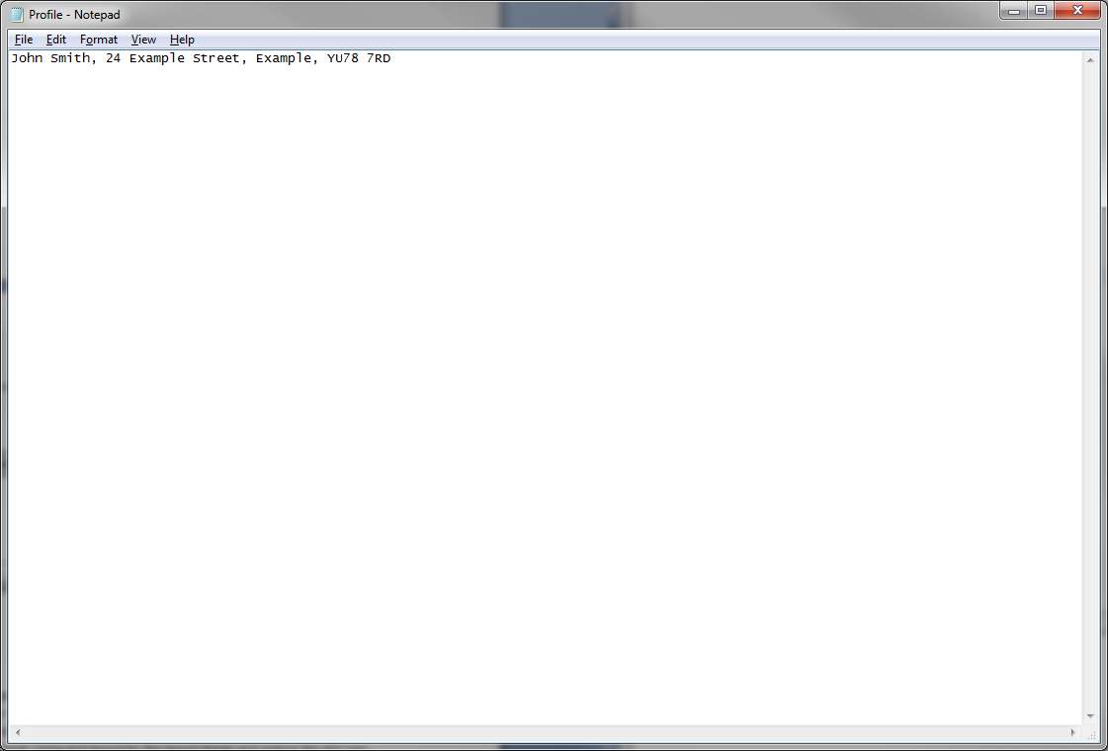

Full Name, Address, City and Postcode successfully registered into the Profile.txt file.

Reflective Notes

I decided to hold the user's profile information in the text file in the format Full Name, Address, City and Postcode. This way it is easier to see the information and who it belongs to.

Test 12 - Changing the Password with the Change Password GUI

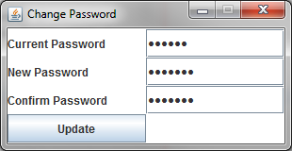

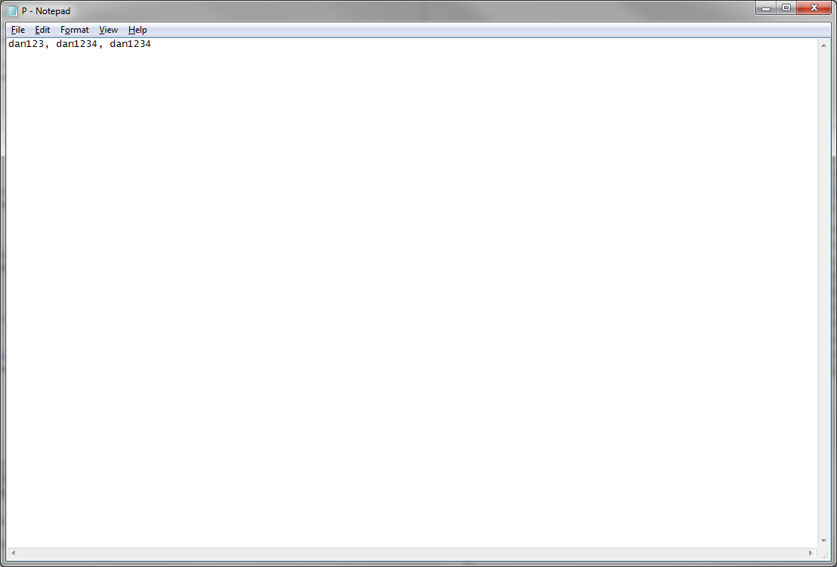

Current Password, New Password and Confirm Password successfully registered into the P.txt file.

Reflective Notes

I decided to hold the user's password information in the text file in the Current Password, New Password and Confirm Password. This way it is easier to see the information and who it belongs to. However due to time constraints I did not set it up to change the password of the customer login, it will simply record the password and desired new password.

Test 13 - Logging with the Staff Login GUI

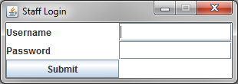

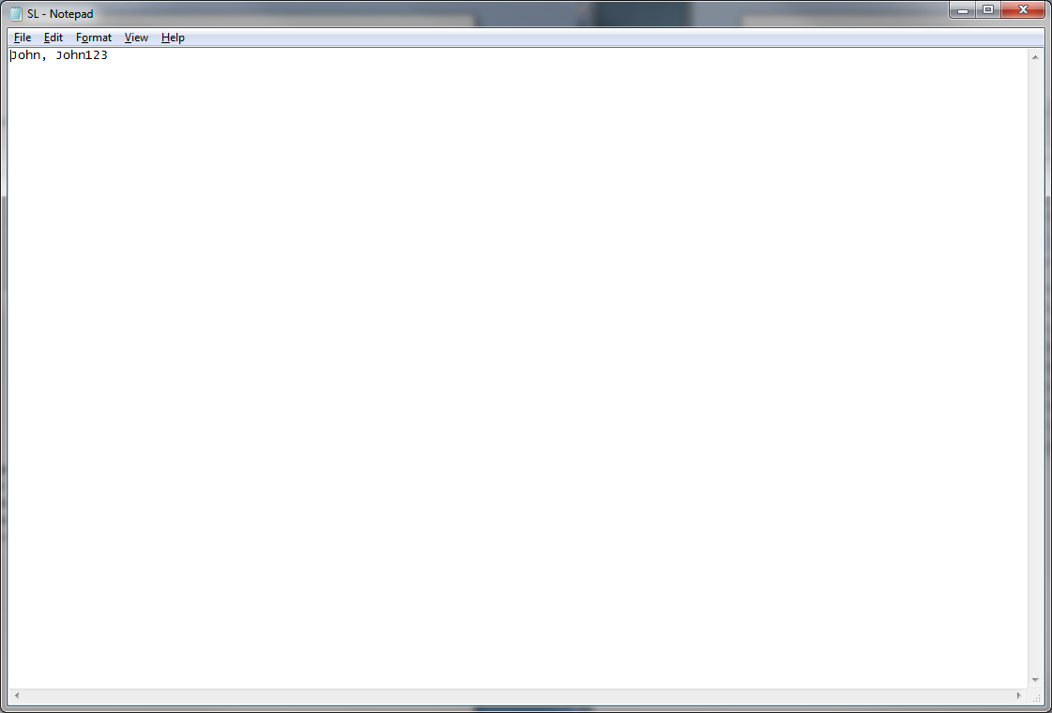

Reflective Notes

Although the user had been registered correctly the file reader in the Submit action Listener was not correct and therefore did not work. Due to time constraint this issue was not fixed making logging in not possible.